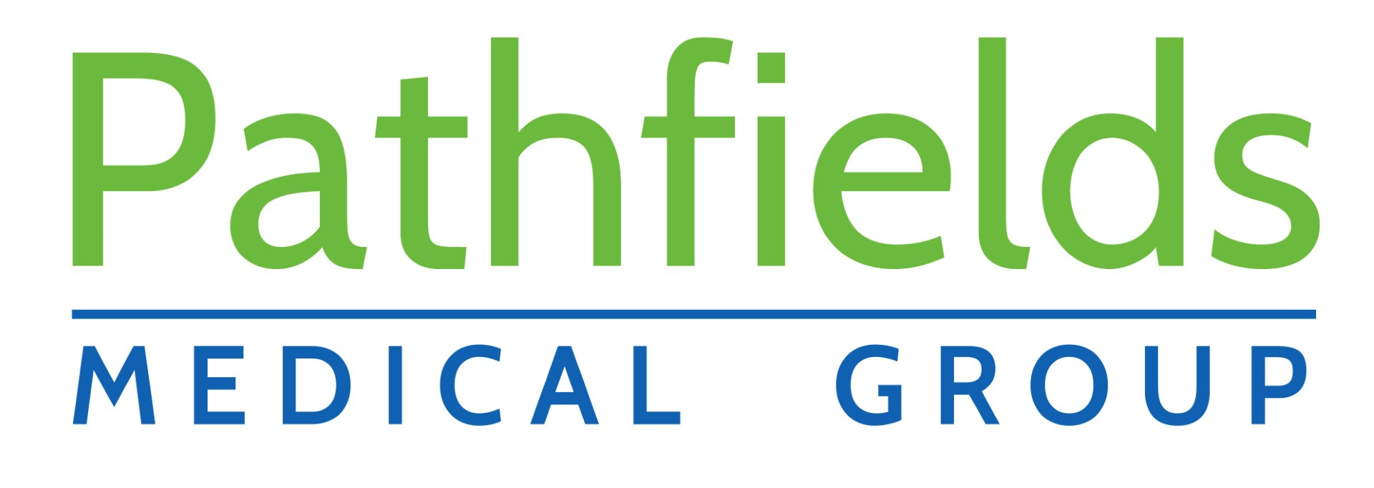

  - Privacy Information Leaflet
Pathfields Medical Group
Plympton Health Center
Mudge Way
PL71AD
01752341474
https://pathfields.nhs.uk

What is a privacy notice?
A privacy notice is a statement that discloses some or all of the ways in which the practice gathers, uses, discloses and manages a patient’s data. It fulfils a legal requirement to protect a patient’s privacy.

Why do we need one?
To ensure compliance with the UK General Data Protection Regulation (UK GDPR), Pathfields Medical Group must ensure that information is provided to patients about how their personal data is processed in a manner which is:
- Concise, transparent, intelligible and easily accessible.
- Written in clear and plain language, particularly if addressed to a child; and
- Free of charge

What is the GDPR?
The UK GDPR replaces the EU GDPR following Brexit and was previously known as the Data Protection Directive 95/46/EC. GDPR harmonised data privacy laws initially across Europe, but now throughout the UK. It has been incorporated into the Data Protection Act 2018 to reshape the approach to data privacy.

How do we communicate our privacy notice?
At Pathfields Medical Group, the practice privacy notice is displayed on our website, through signage in the waiting room, and in writing during patient registration (by means of this leaflet).
We will:
- Inform patients how their data will be used and for what purpose
- Allow patients to opt out of sharing their data, should they so wish

What information do we collect about you?
We will collect information such as personal details, including name, address, next of kin, records of appointments, visits, telephone calls, your health records, treatment and medications, test results, X-rays, etc. and any other relevant information to enable us to deliver effective medical care.

How do we use your information?
Your data is collected for the purpose of providing direct patient care; however, we can disclose this information if it is required by law, if you give consent or if it is justified in the public interest. The practice may be requested to support research; however, we will always gain your consent before sharing your information with medical research databases such as the Clinical Practice Research Datalink and QResearch or others when the law allows.

Maintaining confidentiality
We are committed to maintaining confidentiality and protecting the information we hold about you. We adhere to the UK General Data Protection Regulation (UK GDPR), the NHS Codes of Confidentiality and Security, as well as guidance issued by the Information Commissioner’s Office (ICO).

Risk stratification
Risk stratification is a mechanism used to identify and subsequently manage those patients deemed as being at high risk of requiring urgent or emergency care. Usually this includes patients with long-term conditions, e.g. cancer. Your information is collected by a number of sources, including Pathfields Medical Group; this information is processed electronically and given a risk score which is relayed to your GP who can then decide on any necessary actions to ensure that you receive the most appropriate care.

Invoice validation
Your information may be shared if you have received treatment, to determine which Clinical Commissioning Group (CCG) is responsible for paying for your treatment. This information may include your name, address and treatment date. All of this information is held securely and confidentially; it will not be used for any other purpose or shared with any third parties.

Opt-outs
The national data opt-out programme affords patients the opportunity to make an informed choice about whether they wish their confidential patient information to be used for their individual care and treatment or also used for research and planning purposes. Patients who wish to opt out of data collection will be able to do so as follows:
- Online service – Patients registering need to know their NHS number or their postcode as registered at their GP practice – https://www.nhs.uk/your-nhs-data-matters/manage-your-choice/
- NHS App – For use by patients aged 13 and over (95% of surgeries are now connected to the NHS App). The app can be downloaded from the App Store or Google Play.
- “Print and post” registration form: www.pathfields.co.uk/new-patients/ Photocopies of proof of applicant’s name (e.g., passport, UK driving licence etc.) and address (e.g., utility bill, payslip etc.) need to be sent with the application. It can take up to 14 days to process the form once it arrives.
Unfortunately, the national data opt-out cannot be applied by this organisation.

Accessing your records
You have a right to access the information we hold about you, and if you would like to access this information, you will need to complete a Subject Access Request (SAR). Please ask at reception for a SAR form and you will be given further information. Furthermore, should you identify any inaccuracies, you have a right to have the inaccurate data corrected.
Alternatively, you can sign up for online access and request full online access. Please note, this only includes current records and not historic at present.

What to do if you have any questions
Should you have any questions about our privacy policy or the information we hold about you, you can:
Write to the data controller at Pathfields Medical Group, Crownhill surgery 103 Crownhill Road Plymouth PL53BP

GP practices are data controllers for the data they hold about their patients.

The Data Protection Officer (DPO) for Pathfields Medical Group is Bex Lovewell.

Complaints
In the unlikely event that you are unhappy with any element of our data-processing methods, you have the right to lodge a complaint with the ICO. For further details, visit ico.org.uk and select ‘Make a complaint’
We regularly review our privacy policy, and any updates will be published on our website, in our newsletter and on posters to reflect the changes. This policy is to be reviewed in April 2025

